
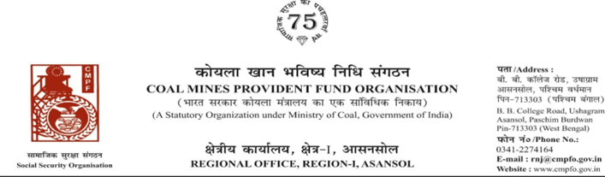
Ref. : CPF/118/Misc/RNJ/L.C./REQ/R-I/ASN/ Date :18/08/2025
To,
The Regional Commissioner
Coal Mines Provident Fund Organisation
PO-Jaripatka, Dist-Nagpur -440014
Maharashtra

Sub:- Inter Regional Transfer of Ledger Card, DA, PS -3 & 4.
Ref:-AGT/JNR/MIC/PF/2025/76 Dated : 12/08/2025
Sir,
In view of the revised Procedures prescribed in Procedure Office Order No-35 Dated-12.02.1975 of CMPF Commissioner,Dhanbad, I am to state that the Ledger Cards of the following members along with Declaration in Form "A" Form-I (Pen),PS-3 & 4 may kindly be forwarded to this office as the member(s) is /are working in this region.
It may kindly be ensured that the posting in the Ledger Cards may be made updated for the periods the member was working in your Region.
SL. No | Name of the Member | CMPF A/C No | Name of the colliery where the member is currently working in | Name of the colliery where the member had earlier worked in | Period of Posting
1 | Sri B. B. Singh | NGP/37/2272 | Mic Jhanjra Project  Colliery  (RNJ/38) | (WCL) | JAN-1988  TO  JUNE-2021
In light of this, we kindly request you to do the needful action and kindly arrange the transfer of his ledger card from previous working zones and update the records accordingly.
Thank you for your attention to this matter.
Encl. :As above Details ( One copy
Yours faithfully

Regional Commissioner - I

